MD WATER SERVICE REPORT
This is a journey of how I work through the Maji_Ndogo water service data on SQL.

Before I start, I
- scan through the data dictionary, and perhaps query a couple of tables to get a feel for the database again.
SELECT *
FROM md_water_services.data_dictionary;

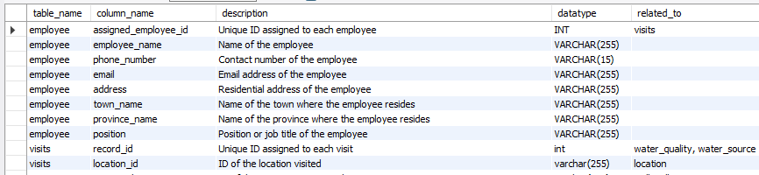

- Bring up the employee table. It has info on all of our workers, but notice that the email addresses have not been added. I will have to send them reports and figures, so I update it. Luckily the emails for our department are easy: first_name.last_name@ndogowater.gov.
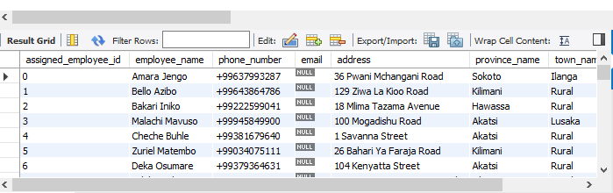
We have to update the database again with these email addresses, so before we do, I use a SELECT query to get the format right, then use UPDATE and SET to make the changes.
SELECT
CONCAT (LOWER (REPLACE(employee.employee_name, " ", ".")),
"@ndogowater.gov") AS Email
FROM employee;
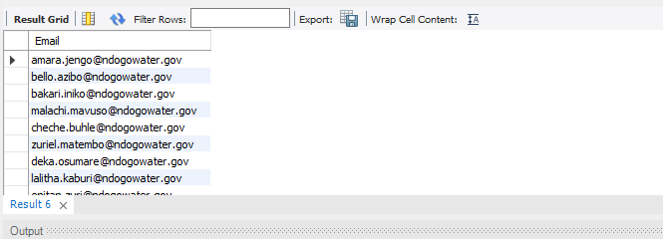
- Use the employee table to count how many of our employees live in each town. Think carefully about what function we should use and how we should aggregate the data
SELECT town_name, count(assigned_employee_id)
FROM employee
GROUP BY town_name;
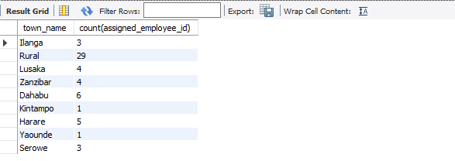
- Use the database to get the employee_ids and use those to get the
names, email and phone numbers of the three field surveyors with the most location visits
-- Firstly look at the number of records each employee collected.
-- Find the correct table, figure out what function to use and how to group, order
-- and limit the results to only see the top 3 employee_ids with the highest number of locations visited.
SELECT assigned_employee_id, count(visit_count) AS number_of_visits
FROM visits
GROUP BY assigned_employee_id
ORDER BY number_of_visits DESC
LIMIT 3;
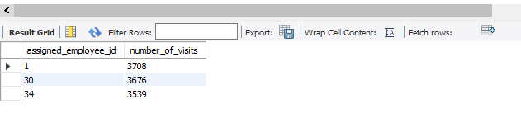
- Make a note of the top 3 assigned_employee_id and use them to create a query that looks up the employee's info. In order to have a column of names, email addresses and phone numbers for our top dogs.
SELECT assigned_employee_id, employee_name, phone_number, email
FROM employee
WHERE assigned_employee_id IN (1, 30, 34);
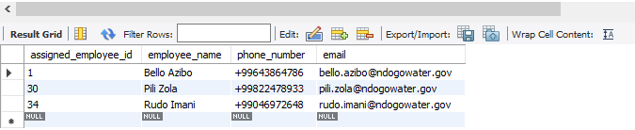

- Analysing locations: Looking at the location table, I focus on the province_name, town_name and location_type to understand where the water sources are in Maji Ndogo. So I create a query that counts the number of records per town
SELECT town_name, count(location_id) AS record_per_town
FROM location
GROUP BY town_name
ORDER BY record_per_town DESC;
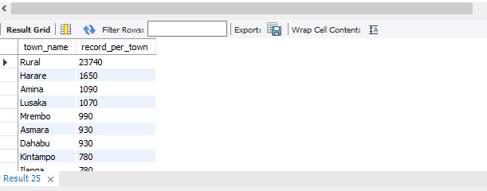

-- Now count the records per province.
SELECT province_name, COUNT(location_id) AS record_per_province
FROM location
GROUP BY province_name
ORDER BY record_per_province DESC;
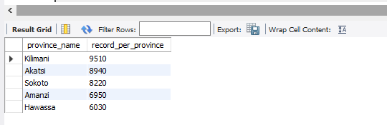

- Find a way to Create a result set showing:
• province_name
• town_name
• An aggregated count of records for each town (consider naming this records_per_town).
• Ensure your data is grouped by both province_name and town_name and Order my results primarily by province_name. Within each province, further sort the towns by their record counts in descending order.*/

SELECT province_name,
town_name,
count(location_id) AS record_per_town
FROM location
GROUP BY province_name, town_name
ORDER BY province_name, record_per_town DESC ;
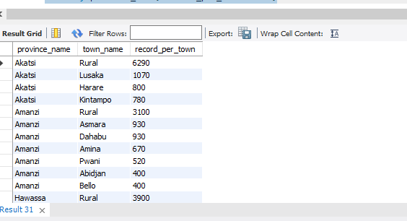

- Finally, look at the number of records for each location type

SELECT location_type, count(location_id) AS record_per_location_type
FROM location
GROUP BY location_type;
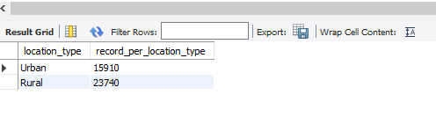
The result reveals that there is more rural sources than urban, but it's really hard to understand those numbers. Percentages are more relatable. So I use SQL as a very overpowered calculator:

SELECT 15910/(15910 + 23740) * 100 AS percentage_urban;
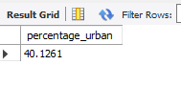
SELECT 23740/(15910 + 23740) * 100 AS percentage_rural;
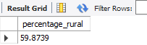
- Diving into the sources
The way I look at this table; we have access to different water source types and the number of people using each source. These are the questions that I am curious about.
A. How many people did we survey in total?
SELECT sum(number_of_people_served) AS Total_people_surveyed
FROM water_source;
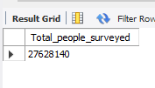
B. How many wells, taps and rivers are there?
SELECT type_of_water_source,
count(source_id) AS type_of_water_source
FROM water_source
GROUP BY type_of_water_source;
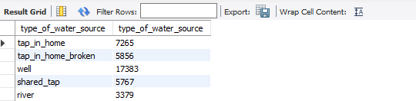

C. How many people share particular types of water sources on average?
SELECT
type_of_water_source,
round(AVG(number_of_people_served), 0) AS Avg_number_of_people_served
FROM water_source
GROUP BY type_of_water_source;
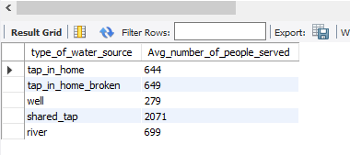

D. How many people are getting water from each type of source?
SELECT type_of_water_source, SUM(number_of_people_served)
AS Total_no_of_people_served
FROM water_source
GROUP BY type_of_water_source
ORDER BY Total_no_of_people_served DESC;

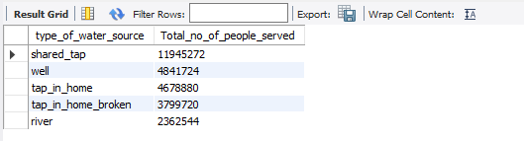

- To make it a bit simpler to interpret, I use percentages. First, I need the total number of citizens then, I use the result of that and divide each of the SUM(number_of_people_served) by that number, times 100, to get percentages.

SELECT SUM(number_of_people_served)
FROM water_source;
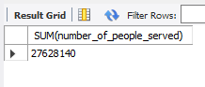

SELECT type_of_water_source, sum(number_of_people_served),
round(SUM(number_of_people_served)/(SELECT SUM(number_of_people_served)
FROM water_source) * 100,0) AS percentage_no_of_people_per_source
FROM water_source
GROUP BY type_of_water_source
ORDER BY percentage_no_of_people_per_source DESC;
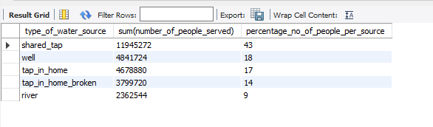

- So I use a window function on the total people served column, converting it into a rank.

SELECT
type_of_water_source,
sum(number_of_people_served),
round(SUM(number_of_people_served)/(SELECT SUM(number_of_people_served)
FROM water_source) * 100,0) AS percentage_no_of_people_per_source,
RANK() OVER(ORDER BY sum(number_of_people_served) DESC) AS Rank_posisiton
FROM
water_source
GROUP BY type_of_water_source;

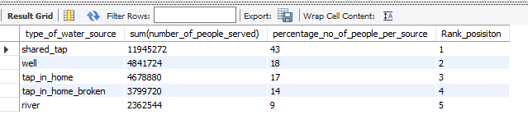
SELECT type_of_water_source, source_id, number_of_people_served,
RANK() OVER (PARTITION BY type_of_water_source
ORDER BY number_of_people_served DESC
) AS rank_within_type
FROM water_source
ORDER BY rank_within_type ASC, number_of_people_served DESC;
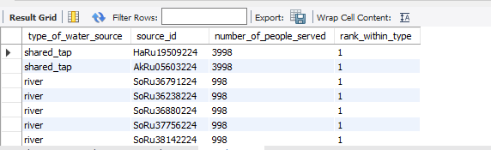

12. Get the first and last dates
SELECT
DATEDIFF(max(date), min(date)) AS days_between
FROM well_pollution;
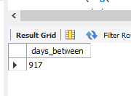
13. Average in Maji Ndogo. Keep in mind that many sources like taps_in_home have no queues.
SELECT
round(avg(nullif(time_in_queue,0)))
FROM visits;
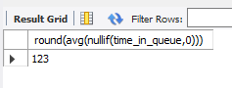

14. he queue times aggregated across the different days of the week.
SELECT
dayname(time_of_record) AS Day_of_the_week,
round(avg(nullif(time_in_queue,0)),0) as AVG_queue
FROM visits
GROUP BY Day_of_the_week
ORDER BY avg_queue desc;
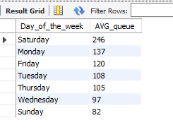

15. What time during the day people collect water.
SELECT hour(time_of_record) AS Hour_of_the_day,
round(avg(nullif(time_in_queue,0)),0) as AVG_queue
FROM visits
GROUP BY Hour_of_the_day
ORDER BY AVG_queue DESC;
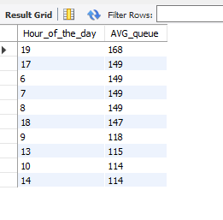
16. Showing the tIme format
SELECT
time_format(Time(time_of_record), '%H:00')AS Hour_of_the_day,
round(avg(nullif(time_in_queue,0)),0) as AVG_queue
FROM visits
GROUP BY Hour_of_the_day
ORDER BY AVG_queue DESC;
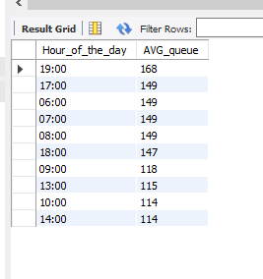

-- To filter a row we use WHERE, but using CASE() in SELECT can filter columns.
-- If you run this query you will see what I mean.

SELECT
TIME_FORMAT(TIME(time_of_record), '%H:00') AS hour_of_day,
DAYNAME(time_of_record),
CASE
WHEN DAYNAME(time_of_record) = 'Sunday' THEN time_in_queue
ELSE NULL
END AS Sunday
FROM visits
WHERE time_in_queue != 0; -- this exludes other sources with 0 queue times.

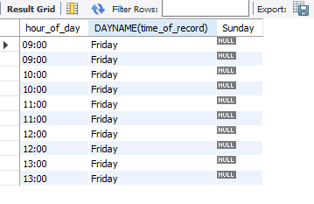
SELECT
TIME_FORMAT(TIME(time_of_record), '%H:00') AS hour_of_day,

-- Sunday
ROUND(AVG(
CASE
WHEN DAYNAME(time_of_record) = 'Sunday' THEN time_in_queue
ELSE NULL
END
),0) AS Sunday,

-- Monday
ROUND(AVG(
CASE
WHEN DAYNAME(time_of_record) = 'Monday' THEN time_in_queue
ELSE NULL
END
),0) AS Monday,

-- Tuesday
ROUND(AVG(
CASE
WHEN DAYNAME(time_of_record) = 'Tuesday' THEN time_in_queue
ELSE NULL
END
),0) AS Tuesday,

-- Wednesday
ROUND(AVG(
CASE
WHEN DAYNAME(time_of_record) = 'Wednesday' THEN time_in_queue
ELSE NULL
END
),0) AS Wednesday,

-- Thursday
ROUND(AVG(
CASE
WHEN DAYNAME(time_of_record) = 'Thursday' THEN time_in_queue
ELSE NULL
END
),0) AS Thursday,

-- Friday
ROUND(AVG(
CASE
WHEN DAYNAME(time_of_record) = 'Friday' THEN time_in_queue
ELSE NULL
END
),0) AS Friday,

-- Saturday
ROUND(AVG(
CASE
WHEN DAYNAME(time_of_record) = 'Saturday' THEN time_in_queue
ELSE NULL
END
),0) AS Saturday

FROM visits
WHERE time_in_queue != 0 -- this excludes other sources with 0 queue times
GROUP BY hour_of_day
ORDER BY hour_of_day;
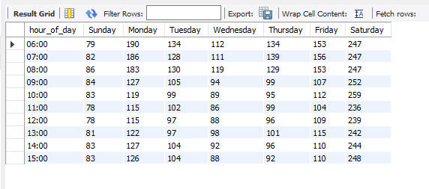

PATTERN SPOTTED.
1. Queues are very long on a Monday morning and Monday evening as people rush to get water.
2. Wednesday has the lowest queue times, but long queues on Wednesday evening.
3. People have to queue pretty much twice as long on Saturdays compared to the weekdays. It looks like people spend their Saturdays queueing
for water, perhaps for the week's supply?
4. The shortest queues are on Sundays, and this is a cultural thing. The people of Maji Ndogo prioritise family and religion, so Sundays are spent
with family and friends.

WATER ACCESSIBILITY AND INFRASTRUCTURE SUMMARY REPORT
This survey aimed to identify the water sources people use and determine both the total and average number of users for each source.
Additionally, it examined the duration citizens typically spend in queues to access water

INSIGHTS
1. Most water sources are rural.
2. 43% of our people are using shared taps. 2000 people often share one tap.
3. 31% of our population has water infrastructure in their homes, but within that group, 45% face non-functional systems due to issues with pipes,
pumps, and reservoirs.
4. 18% of our people are using wells of which, but within that, only 28% are clean..
5. Our citizens often face long wait times for water, averaging more than 120 minutes.
6. In terms of queues:
- Queues are very long on Saturdays.
- Queues are longer in the mornings and evenings.
- Wednesdays and Sundays have the shortest queues.

START OF OUR PLAN
1. We want to focus our efforts on improving the water sources that affect the most people.
- Most people will benefit if we improve the shared taps first.
- Wells are a good source of water, but many are contaminated. Fixing this will benefit a lot of people.
- Fixing existing infrastructure will help many people. If they have running water again, they won't have to queue, thereby shorting queue times for others. So we can solve two problems at once.
- Installing taps in homes will stretch our resources too thin, so for now, if the queue times are low, we won't improve that source.
2. Most water sources are in rural areas. We need to ensure our teams know this as this means they will have to make these repairs/upgrades in
rural areas where road conditions, supplies, and labour are harder challenges to overcome.

PRACTICAL SOLUTIONS
1. If communities are using rivers, we can dispatch trucks to those regions to provide water temporarily in the short term, while we send out crews to drill for wells, providing a more permanent solution.
2. If communities are using wells, we can install filters to purify the water. For wells with biological contamination, we can install UV filters that kill microorganisms, and for *polluted wells*, we can install reverse osmosis filters. In the long term, we need to figure out why these sources are polluted.
3. For shared taps, in the short term, we can send additional water tankers to the busiest taps, on the busiest days. We can use the queue time pivot table we made to send tankers at the busiest times. Meanwhile, we can start the work on installing extra taps where they are needed.
According to UN standards, the maximum acceptable wait time for water is 30 minutes. With this in mind, our aim is to install taps to get queue times below 30 min.
4. Shared taps with short queue times (< 30 min) represent a logistical challenge to further reduce waiting times. The most effective solution, installing taps in homes, is resource-intensive and better suited as a long-term goal.
5. Addressing broken infrastructure offers a significant impact even with just a single intervention. It is expensive to fix, but so many people can benefit from repairing one facility. For example, fixing a reservoir or pipe that multiple taps are connected to. We will have to find the commonly affected areas though to see where the problem actually is.

